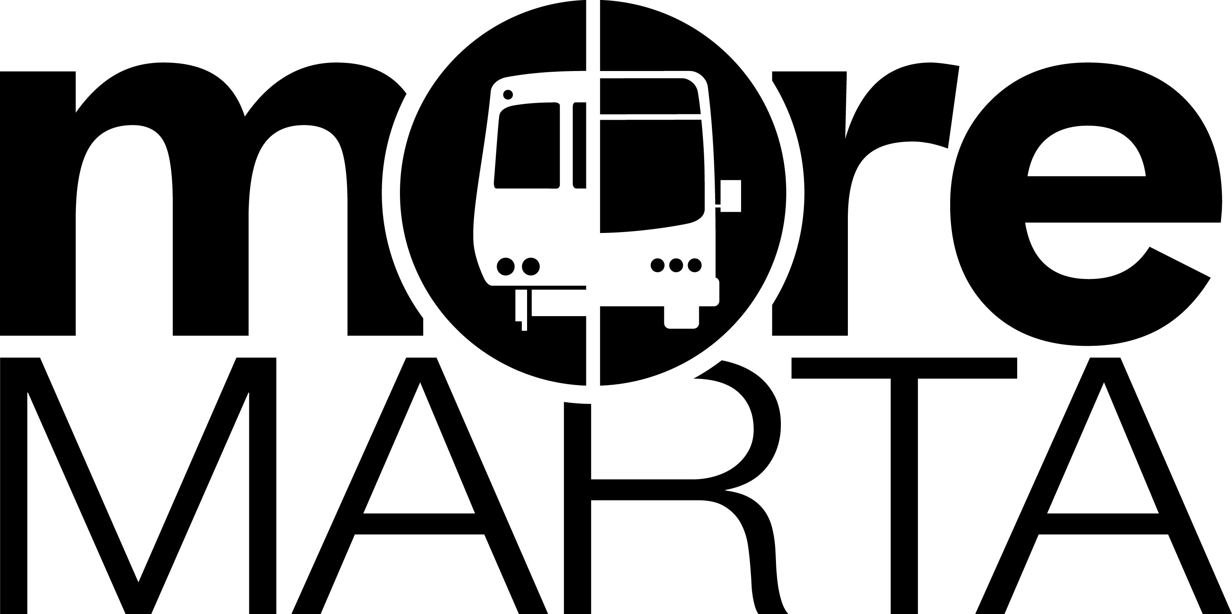
MARTA Planning, Attn: Ryan Sager, 2424 Piedmont Rd., NE, Atlanta, GA 30324 –
Fax: 404-848- 4179 Website: www.itsmarta.com/moremarta/
City of Atlanta Listening Sessions Survey
The following questions are meant to guide the discussion for the allocation of funds collected from the successful City of Atlanta MARTA Sales Tax Referendum. This additional ½ percent sales tax for 35 years will raise $2.5 to $3.5 billion for transit within Atlanta. This survey presents a list of projects that could be implemented with these funds. We want your input on the projects that are most important to you. Please rate these projects according to the directions outlined below. In addition, describe any other projects that you believe we should consider. Thank you for your help.
- How important is it to you to that MARTA implement each of the transit projects listed below? (Place an “X” in one rating column next to each project.)
- What are your top 3 most important transit projects for the new funds? (Place an “X” next to 3 projects in the “Top 3” column.)
 | Very Important | Somewhat Important | Neutral | Not Important | Not at all Important | Top 3  Projects
Expansion of Atlanta Streetcar/Light Rail, incl. the Atlanta BeltLine Loop | [ ] | [ ] | [ ] | [ ] | [ ] | [ ]
Introduction of light rail transit along Clifton Corridor from Lindbergh to Avondale Station | [ ] | [ ] | [ ] | [ ] | [ ] | [ ]
Extension of heavy rail west from HE Holmes Station to I-285 | [ ] | [ ] | [ ] | [ ] | [ ] | [ ]
Bus rapid transit (BRT) on Northside Dr. and Metropolitan Pkwy. BRT primarily uses dedicated lanes and is less affected by traffic conditions than normal routes. | [ ] | [ ] | [ ] | [ ] | [ ] | [ ]
Introduction of bus rapid transit on I-20 East | [ ] | [ ] | [ ] | [ ] | [ ] | [ ]
Increase the frequency of existing bus routes | [ ] | [ ] | [ ] | [ ] | [ ] | [ ]
Introduce new bus routes | [ ] | [ ] | [ ] | [ ] | [ ] | [ ]
Offer community circulator service  A circulator route provides local community and links the community to larger bus routes. | [ ] | [ ] | [ ] | [ ] | [ ] | [ ]
Introduction of rapid transit on Peachtree St, Metropolitan Pkwy, Cleveland Ave, Cascade Rd, and Campbellton Rd.  Provides fast and frequent service on major roadways. | [ ] | [ ] | [ ] | [ ] | [ ] | [ ]
Other project(s) that is not listed (please describe) _________________ | [ ] | [ ] | [ ] | [ ] | [ ] | [ ]
- What are top 3 locations within the City of Atlanta where you would most prefer to see increased transit service? Please be as detailed as possible when describing each location. For example, include names of neighborhoods, streets, landmarks, etc.
1.
2.
3.
- The list below describes eleven types of service improvements. Please put an “X” next to the top 3 service improvements that are most important to you.
[ ] Frequency of bus service on weekdays before 9:00pm | [ ] Express bus service (a limited number of stops)
[ ] Frequency of bus service on weekday nights after 9:00pm | [ ] Extending hours of operation
[ ] Frequency of bus service on weekends | [ ] Increased seating capacity on buses
[ ] Frequency of rail service on weekdays before 9:00pm | [ ] Increased seating capacity on trains
[ ] Frequency of rail service on weekday nights after 9:00pm | [ ] Expanding the MARTA service area
[ ] Frequency of rail service on weekends | [ ] Other (please describe) _____________________  _____________________________________________
- What is your zip code? __________________________________________
- Do you typically ride: [ ] Rail Only [ ] Bus Only [ ] Both Bus and Rail

- Gender: [ ] Male [ ] Female

- Age: [ ] 16-24 [ ] 25-34 [ ] 35-44 [ ] 45-54 [ ] 55-64 [ ] 65 or over

- About how many days per week do you ride MARTA? _____________
- Please describe other suggestions you would like to offer in the space provided below.

